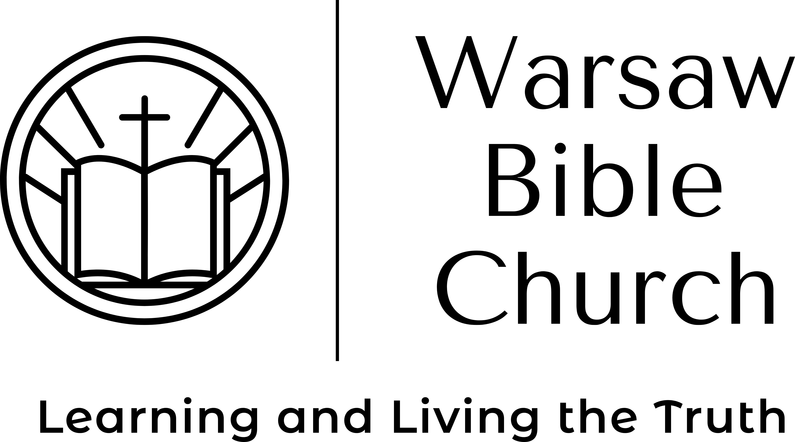 |  |  |  | What is the Bible?  Pastor Jason McCray

Physical Perspective
It is a collection of 66 books, written over a 1500 year period, written in 3 languages (Hebrew, Greek, Aramaic), on 3 continents (Asia, Europe, Africa), by over 40 human authors.

Spiritual Perspective
God used human agents to produce a reliable account of how a holy God is able to redeem sinful man for His glory. The Bible is the inspired, inerrant, infallible and authoritative book from God.

Inspired
The Bible is given by God to mankind through the Holy Spirit (2 Tim. 3:16; 2 Pet. 1:21). Proof: Consider how a book written over a 1500 year period by over 40 authors in 3 languages on 3 continents is a unified book without contradiction. It had to have one editor (God) and one supervisor (the Holy Spirit).

Inerrant
The Bible is without error in its claims about God, Jesus, this life and the life to come (Psalm 19:7; 119:160; John 17:17). Proof: Consider archeology and history, all proving the reliability of the Bible.

Infallible
The Bible will accomplish everything it says will happen (Isaiah 55:11; Matt. 5:18; John 10:35b). Proof: Consider all the prophecies made and fulfilled literally and perfectly.

Authoritative
The Bible is the final authority for all of life’s questions and issues (Hebrews 4:12; Psalm 19:7-13). Proof: Consider the thousands of testimonies and lives transformed by the Bible.

What is the Bible good for?
It can give you faith (Romans 10:17).
It can save your soul (James 1:21).
It can equip you for all things (2 Timothy 3:17).
It can lead you to the blessings of God (James 1:25).
16155 Waggoner Rd
Warsaw, MO 65355
 |  | 660-723-3719
 |  | pastorjmccray@gmail.com
 |  | Warsawbiblechurch.org

